
Course Code: ECE281
Project Name: Smart Waste Segregation System

Submitted by:
- Saad Mohammad Shibli – 12313305
- Anurag Kumar – 12312659
- Mihir Kumar – 12320906
- Sudhanshu Ranjan - 12313589

Date: 14. 04. 2025

ABSTRACT:
This project presents an automated waste segregation system that utilizes Arduino technology to classify waste efficiently into three categories: wet, dry, and metallic. The system utilizes a combination of sensors, including ultrasonic sensors for object detection, soil moisture sensors to detect damp waste, and metal detectors for identifying metallic items. Upon detection, servo motors are activated to direct the waste into the appropriate bins. This automation aims to enhance waste management practices by reducing human intervention, minimizing health risks associated with manual sorting, and promoting environmental sustainability through effective recycling processes.

INTRODUCTION:
With the rapid urbanization and increasing population, the amount of waste generated in urban areas has surged significantly. Improper waste management not only harms the environment but also poses serious health risks to humans and animals. One of the primary challenges in effective waste disposal is the segregation of waste into proper categories, such as biodegradable, non-biodegradable, and metallic waste.
Traditionally, waste segregation is done manually, which is not only labour-intensive but also unhygienic and prone to errors. To overcome these challenges, there is a growing need for automation in the waste management process.
This project aims to design and develop an automated waste segregation system using Arduino and various sensors. The system can identify and segregate waste into three categories: wet (biodegradable), dry (non-biodegradable), and metallic. By using a soil moisture sensor for detecting wet waste, a metal detector for metallic objects, and an ultrasonic sensor to sense the presence of any object, the system ensures accurate and contactless waste sorting.
The overall objective of this project is to create a smart and efficient waste management system that not only reduces the burden on human labour but also promotes recycling and a cleaner environment.

COMPONENT USED:
Hardware Components & Their Roles
Component | Purpose / Function
Arduino UNO | Acts as the main microcontroller that controls all connected sensors and motors.
IR Sensor | Detects metallic waste based on the reflection of infrared light.
Rain Sensor / Moisture Sensor | Detects the presence of wet waste through moisture or water contact.
Proximity Sensor | Detects if any object/waste item is placed on the conveyor belt.
Ultrasonic Sensor | Measures the fill level of the dustbins and triggers an alert if full.
Servo Motor | Controls the opening/closing of the bin lid or diverter gate to sort waste.
Stepper Motor | Rotates bins or aligns the conveyor belt to the correct bin for dumping waste.
Conveyor Belt | Transports waste through the sensor zone for real-time identification and sorting.
Buzzer | Gives an alert sound when bins are full or in case of malfunction.
Power Supply | Powers the Arduino board and all connected components.
Jumper Wires | Used to connect sensors and modules to the Arduino for signal transmission.
Dustbins (3 types) | Separate bins to collect wet, dry, and metallic waste after classification.

WORKING PRINCIPLE:
Step-by-Step Working Process
1. Waste Placement
- The garbage is placed manually or automatically at the starting point of the conveyor belt.
- A proximity sensor detects the presence of an object and signals the system to start the process.

2. Activation of Conveyor Belt
- The conveyor belt starts moving forward via a motor.
- Waste is carried under the sensors one by one for classification.

3. Sensor Detection Phase
- As the waste moves on the conveyor:
  - Rain or Moisture Sensor checks for wet waste.
  - If no moisture is detected, the IR sensor checks for metallic waste.
  - If not metallic, the item is classified as dry waste (like plastic, paper).

4. Decision Logic via Arduino
- Based on sensor data, the Arduino decides:
  - If wet → send to wet bin
  - If metal → send to metal bin
  - Else → send to dry bin

5. Servo / Stepper Motor Activation
- The servo motor opens the bin lid, or the stepper motor rotates the conveyor end to align with the correct bin.
- Waste is dropped into the correct bin.

6. Fill-Level Monitoring
- An ultrasonic sensor constantly checks how full each bin is.
- If any bin reaches the threshold, it triggers a buzzer to alert the user or system operator.

7. System Reset
- Once the waste is dropped and the path is cleared:
  - The conveyor belt resets to the initial position.
  - The system waits for the next waste item.

CIRCUIT DIAGRAM:
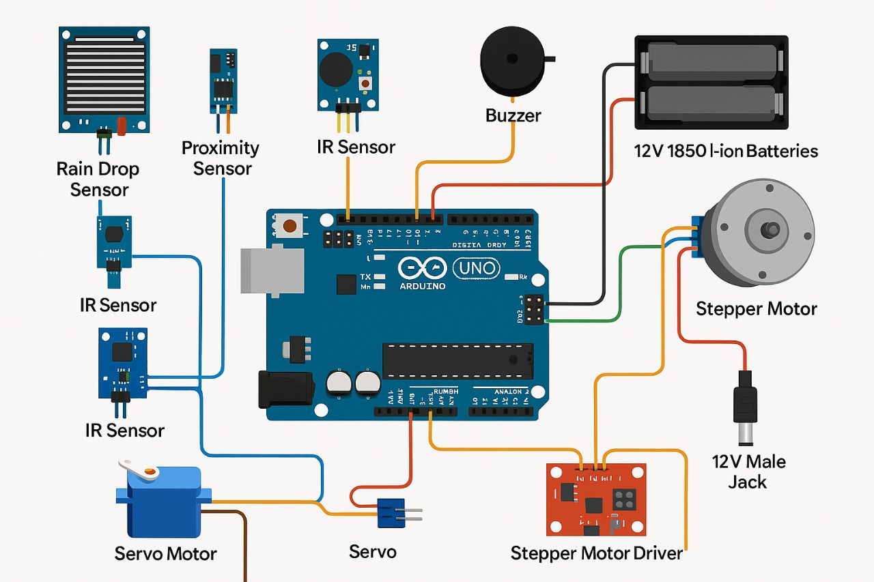

Description of Circuit Layout:
- Main Controller – Arduino UNO
  - Acts as the central hub
  - All sensors and motors are connected to the digital and analog pins
- Sensors Setup
  - Proximity Sensor (to detect waste presence): connected to digital pin D2
  - Rain/Moisture Sensor (wet waste): connected to analog pin A0
  - IR Sensor (metal waste): connected to digital pin D3
  - Ultrasonic Sensor (bin fill level):
    - Trigger pin → D4
    - Echo pin → D5
- Motor Connections
  - Servo Motor (for lid control or gate movement):
    - Signal pin connected to D6
  - Stepper Motor (for bin alignment):
    - Connected via Motor Driver Module (like ULN2003) to D7–D10
- Output Devices
  - Buzzer (for full-bin alert): connected to D11
- Power Supply
  - 5V and GND pins of Arduino used to power sensors and modules.
  - External power bank or adapter (9V–12V) for motors to prevent overloading Arduino.

HARDWARE IMPLEMENTATION:
Explanation of the Physical Setup:
Our prototype consists of a conveyor belt system, connected sensors, and bins. Here's how everything is placed and works together:
Physical Setup Details
- Conveyor Belt Frame
  - Base structure made of cardboard, wood, or plastic.
  - Mounted with a belt (rubber/plastic) driven by a DC motor or stepper motor.
  - Waste moves along the belt to reach the sensors.
- Sensor Zone
  - Sensors are mounted above or beside the conveyor belt:
    - Proximity Sensor at the start, to detect when waste is loaded.
    - Moisture/Rain Sensor right after, to check if the waste is wet.
    - IR Sensor after that, to detect metallic content.
- Control Unit
  - Arduino UNO is fixed near the base of the setup.
  - All sensors and motors are connected to the Arduino via jumper wires.
  - Mounted neatly on a breadboard or cardboard for easy wiring.
- Sorting Mechanism
  - After classification, the servo motor moves a flap/gate, or a stepper motor rotates a bin base.
  - Waste is dropped into one of the 3 bins: Wet, Dry, or Metallic.
- Dustbins
  - Three color-coded or labelled bins are placed at the end of the conveyor.
  - The correct bin opens or aligns when waste is ready to drop.
- Buzzer & Alerts
  - A buzzer is installed to beep when any bin is full, based on ultrasonic sensor feedback.

CODE EXPLANATION:
1. Initialization (Setup Section)
- Define and initialize pins for:
  - Sensors (Rain, IR, Proximity, Ultrasonic)
  - Motors (Servo, Stepper)
  - Buzzer
- Set pin modes using pinMode()
- Begin Serial.begin(9600) for debugging

2. Detecting Waste Entry
- Use proximity sensor to detect waste object:
if (digitalRead(proximityPin) == HIGH) {
// Waste detected → start conveyor
}
- Turn on conveyor belt motor

3. Waste Type Detection (Sensor Analysis)
- Check moisture sensor value:
if (analogRead(rainSensor) > threshold) {
wasteType = "Wet";
}
- If not wet, check IR sensor:
if (digitalRead(irSensor) == HIGH) {
wasteType = "Metal";
}
- If neither → classify as Dry waste

4. Motor Action for Sorting
- Based on the detected wasteType:
if (wasteType == "Wet") {
servo.write(wetBinPosition);
}
else if (wasteType == "Metal") {
servo.write(metalBinPosition);
}
else {
servo.write(dryBinPosition);
}
- Or rotate stepper motor to correct bin

5. Bin Full Check (Ultrasonic Sensor)
- Measure distance to waste pile in each bin:
long duration = pulseIn(echoPin, HIGH);
int distance = duration * 0.034 / 2;
if (distance < 10) {
digitalWrite(buzzer, HIGH);
}
- If full → turn on buzzer alert
6. Reset & Ready for Next Waste
- Conveyor stops momentarily, then resets
- System is ready for next waste item

BENEFITS OF PROJECT:
Key Advantages:
- Efficient Sorting: Automatically separates wet, dry, and metal waste without human intervention.
- Reduces Human Contact: Minimizes exposure to harmful or unsanitary waste.
- Time-saving: It speeds up waste management operations.
- Real-Time Monitoring: Sensors provide the live status of bin levels.
- Eco-Friendly: Promotes recycling and reduces environmental pollution.
- Cost-Effective in the Long Run: It lowers operational and labour costs in large-scale applications.

REAL-LIFE APPLICATIONS:
Where This Can Be Implemented:
- Smart Cities: Integrated into municipal waste handling systems.
- Colleges & Schools: For campus cleanliness and education.
- Shopping malls & Airports: High footfall areas need intelligent systems.
- Hospitals: To automate and safely manage biomedical waste.
- Corporate Offices: Promote a green and sustainable workplace.

CONCLUSION:
- We have successfully built a smart waste segregation system using Arduino, sensors, and conveyor belt automation.
- It can detect the type of waste (wet, dry, metal), sort it accordingly, and alert when bins are full.
- This project contributes to a cleaner environment and efficient urban waste management and demonstrates the power of automation in solving real-world problems.

REFRENCES:
YouTube - https://www.youtube.com/watch?v=4XedfXtPxLQ

